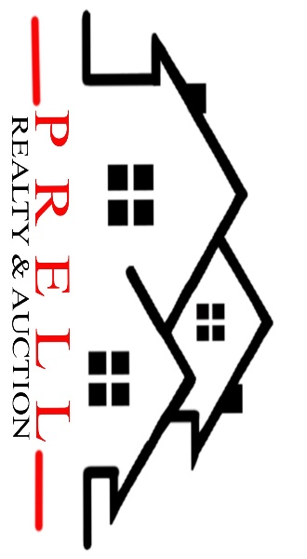

1042 Pony Express Hwy, Marysville KS 66508

Address: 1510 Debbie Ln. Marysville
Asking Price: $__215,000__________
# Of Bedrooms | 4
# of Bathrooms | 2
Square Footage | 2300
Year Built | 1974
Property Tax | 2850
Co. Tax Appraisal $ | 151,930

Type of A/C__Central _____________________
Type of Heat__ in ceiling__ _____________________
Type of Water Heater__electric ____ _____________________
Floor Covering
X | Carpet
X | Tile
X | Hardwood
X | Linoleum

NOTES
Roof done in 2022

Roof
 | Metal
 | Shingle
 | Slate
 | Tile
X | Other

Exterior
 | Brick
 | Concrete
 | Metal
 | Shingle
 | Stucco
 | Vinyl
 | Wood
X | Other

Parking
 | Carport
2 | Garage Attached
 | Garage detached
 | Off Street
 | On Street

Indoor Features
 | Attic
 | Ceiling Fans
 | Double Pane Windows
2 | Fireplace
 | Intercom System
 | Jetted tub
 | Security System
 | Skylights
X | Vaulted Ceiling

Architectural Style
 | Bungalow
 | Colonial
 | Contemporary
 | Loft
 | Victorian
X | Ranch
 | Split-Level
 | Other

Outdoor Amenities
X | Porch
X | Barbecue Area
X | Deck
X | Fenced Yard
 | Pool
 | Sprinkler System

Basement
X | Finished
 | Unfinished
 | Partially Finished
 | None
 | Crawl Space
 | Strom shelter

Appliances
X | Dishwasher
 | Dryer
 | Freezer
X | Garbage Disposal
X | Microwave
X | Range/Oven
X | Refrigerator
 | Trash Compactor
 | Washer

Rooms
 | Breakfast Nook
 | Dining Room
X | Family Room
X | Laundry Room
X | Master Bath
 | Mud Room
 | Office
X | Pantry
X | Walk-in Closet

